
APPLICATIONS DEVELOPMENT
PRACTICE 4

Final Exam

Name: Moipone
Surname: Kabai
Student number: 215203569

Exam date: 20 November 2020
Question 1
  - Algorithm to check if two binary trees are identical or not:
- Create a data structure to store a binary tree node, such as class node {
Node(int key){
This.key = key}}.
- Create a class with function to check if two given binary trees are identical or not identical, such as public static boolean identical (node a, node b){
If (a == null && b == null){
Return true;}}
- If you check if both trees are empty, and the values of their root node match, the true result should be returned.
- If both trees are not empty and values of their roots are the same, true will be returned.
- Compare their left and right subtrees.
- Construct the first and second tree, then if their tree structure is the same return identical, else non-identical.
- The idea is to traverse both tress and compare values of their nodes.
- If the value matches, the left subtree of tree A is recursively checked to see if it is identical to the left subtree of tree B, and the right subtree of tree A is identical to the right subtree of tree B.
- If values at their root nodes differ, the tree violates data property and cannot be identical.

  - In post-order traversal, the left child is visited first, then right child and last parent.
Therefore the post-fix expression is: $5^{y}\left(2*\left(3y\right)\right)*\left(-2\right)+0$
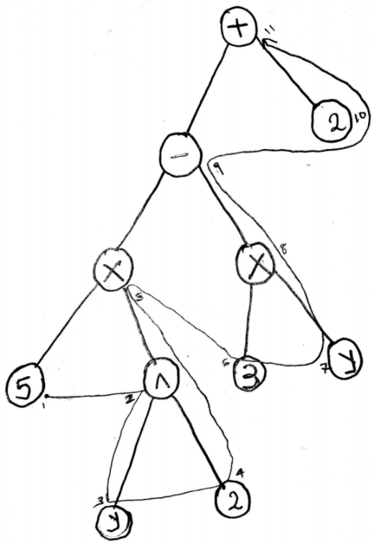
  - Pre-order: {3, 6, 8, 5, 4, 2, 7, 9}
In-order: {5, 8, 6, 4, 3, 2, 9, 7}
Root is first element in pre-order.
Left subtree
Pre-order: {6, 8, 5, 4}
In-order: {5, 8, 6, 4}
Right subtree
Pre-order: {2, 7, 9}
In-order: {2, 9, 7}
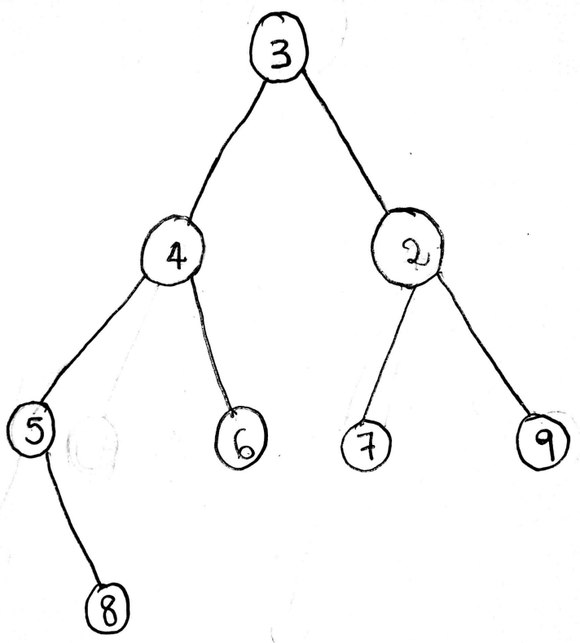
Question 2
 | S1 | S2
No. of Comparison (Bubble Sort) | 13 | 18
No. of Comparison (Quick Sort) | 6 | 10

Question 3
0 |  | 0 | 700 | 0 | 700 | 0 | 700 | 0 | 700 | 0 | 700 | 0 | 700
1 |  | 1 | 50 | 1 | 50 | 1 | 50 | 1 | 50 | 1 | 50 | 1 | 50
2 |  | 2 |  | 2 |  | 2 |  | 2 |  | 2 |  | 2
3 |  | 3 |  | 3 |  | 3 |  | 3 |  | 3 |  | 3
4 |  | 4 | 73 | 4 | 73 | 4 | 73 | 4 | 73 | 4 | 73 | 4 | 73
5 |  | 5 |  | 5 |  | 5 |  | 5 |  | 5 |  | 5
6 |  | 6 |  | 6 |  | 6 |  | 6 |  | 6 |  | 6

